**Unit II - Process Management**

**Process Scheduling**

The process scheduling is the activity of the process manager that handles the removal of the running process from the CPU and the selection of another process on the basis of a particular strategy.

The Operating System maintains the following important process scheduling queues

* **Job queue** − This queue keeps all the processes in the system.
* **Ready queue** − This queue keeps a set of all processes residing in main memory, ready and waiting to execute. A new process is always put in this queue.
* **Device queues** − The processes which are blocked due to unavailability of an I/O device constitute this queue.

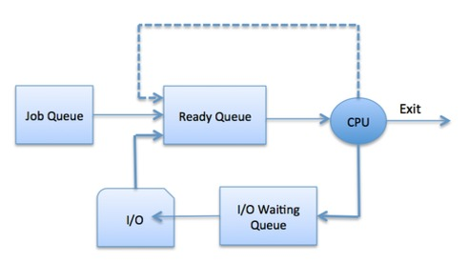

Scheduling fell into one of the two general categories:

* **Non Pre-emptive Scheduling**: When the currently executing process gives up the CPU voluntarily.
* **Pre-emptive Scheduling:**When the operating system decides to favour another process, pre-empting the currently executing process.

There are three types of schedulers available:

* **Long Term Scheduler:** Long term scheduler runs less frequently. Long Term Schedulers decide which program must get into the job queue. From the job queue, the Job Processor, selects processes and loads them into the memory for execution. Primary aim of the Job Scheduler is to maintain a good degree of Multiprogramming. An optimal degree of Multiprogramming means the average rate of process creation is equal to the average departure rate of processes from the execution memory.
* **Short Term Scheduler:** This is also known as CPU Scheduler and runs very frequently. The primary aim of this scheduler is to enhance CPU performance and increase process execution rate.
* **Medium Term Scheduler**: This scheduler removes the processes from memory (and from active contention for the CPU), and thus reduces the degree of multiprogramming. At some later time, the process can be reintroduced into memory and its execution van be continued where it left off. This scheme is called **swapping**. The process is swapped out, and is later swapped in, by the medium term scheduler.